|  |
| --- |
| IFMR RURAL FINANCE |
| Application |
|  |
| **IFMR Rural Finance** |
| **10/19/2016** |

|  |
| --- |
|  |

Contents

Process Diagram 3

1. Stage definition 4

2. Stage-role access 4

3. Application Queue 4

3.1 UI specification 4

3.2 Screenshot 4

3.3 Functional requirements 5

3.4 Upload 6

3.5 Download 6

3.6 Reports 6

4. Capturing Application data 7

4.1 UI requirements 7

4.2 Screenshots 40

4.3 Functional requirements 45

4.4 Uploads 46

4.5 Downloads 46

4.6 Reports 46

5. PSYCHOMETRIC TEST 46

5.1 UI specification 46

5.2 Screenshot 46

5.3 Functional requirements 46

5.4 Upload 46

5.5 Download 46

5.6 Reports 46

# Process

1. Process Flowchart



1. Process Steps
2. Loan Officer logs in and will be able to view all profiles accepted in Screening review process or are auto approved during screening
3. Lo can search/sort based on following parameters

* Applicant Name
* Business Name
* URN
* Area
* City/Village/Town
* Pincode

1. All search parameters will have a sort/arrange facility
2. LO will click on the desired profile to select the customer. Screening data of that customer will be auto-populated and screening fields will be displayed.
3. LO will enter details to capture application data.
4. On clicking ‘submit’ the system will generate URN and compute Risk Score 2 (Screening Score)
5. If Risk Score 2 fulfils the auto-approval criteria, the profile is directly sent to the Field appraisal stage, and will be displayed in the pending for field appraisal queue.
6. If Risk Score 2 does not fulfil the auto-approval criteria, the profile is sent to the application review stage if LO chooses Accept option, and will be displayed in the pending for screening review queue. Lo will have the option to Hold/Reject/Sendback in addition to Accept.
7. If LO holds the application, it will remain in queue with “on Hold” tag.
8. If LO Rejects the application, it will go to Rejected application queue
9. If LO Sendback, he should get option to select one of the past stages (Screening/screening review in this case) and the application should move to that stage with “Sent Back from Application stage” tag.

# Stage definition

|  |  |
| --- | --- |
| **Stage** | **Description** |
| Application Queue | The Loan Officer selects a profile from the screening completed list |
| Capture Details | The loan officer captures data and submits the same for risk score calculation |

# Stage-role access

|  |  |
| --- | --- |
| **Stage** | **Applicable Role** |
| Application Queue | Loan Officer |
| Capture Details | Loan Officer |

# 

# Application Queue

## UI specification

|  |  |  |  |  |
| --- | --- | --- | --- | --- |
| **Field name** | **Section** | **Data Type** | **Attribute** | **Population logic** |
| Applicant Name | Application Queue | Text | Sort/search | from screening but Editable stage |
| Business Name | Application Queue | Alphanumeric | Sort/search | from screening but Editable stage |
| Customer ID | Application Queue | Alphanumeric | Sort/search | from screening but Editable stage |
| Area | Application Queue | Text | Sort/search | from screening but Editable stage |
| City/Village/ Town | Application Queue | Text | Sort/search | from screening but Editable stage |
| Pincode | Application Queue | Numeric |  | from screening but Editable stage |

## Screenshot

* + 1. Search Page

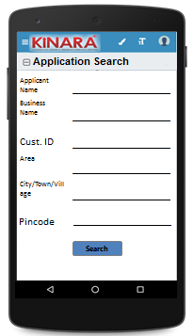

* + 1. Application Queue

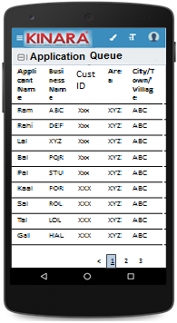

## Functional requirements

**Loan Officer** logs in

* The Loan Officer opens the process dash board, and clicks on Application queue
* If the Loan Officer performs a search without selecting any parameter, then all cases with status ‘Pending for Application’ to be displayed in a tabular format.
* If the Loan Officer searches with ‘Applicant name’, ‘Business name’ or ‘URN no’, then all matching records that are ‘Pending for Application’ (including existing customers) to be displayed in a tabular format.
* The Loan Officer can **search and sort** the profiles based on the following parameters: URN no, Applicant Name, Business Name, Area, City/Village/Town.
* The Loan Officer then selects a profile from the application queue. The queue table should have applicant name, business name, URN No, Area, City/Town/Village as column names.
* All the columns will have **sorting** facility.

## Upload

-NA-

## Download

-NA-

## Reports

-NA-

# Capturing Application data

## UI requirements

|  |  |  |  |  |  |  |  |  |
| --- | --- | --- | --- | --- | --- | --- | --- | --- |
| **Entity** | **Tab** | **Sub tab** | **Section** | **Fields** | **Field Value** | **Mandatory** | **Conditional Mandatory** | **Remarks** |
| APPLICANT | KYC Details |  |  | Aadhar No | Numeric | Yes |  | from screening but Editable |
| Document Capture | Upload | Yes |  | from screening but Editable |
| Pan Number | Alpha numeric | Yes |  | from screening but Editable |
| Document Capture | Upload | Yes |  | from screening but Editable |
| ID Type | Dropdown |  |  | from screening but Editable |
| ID No | Alpha numeric |  | Yes | from screening but Editable |
| Valid Up to | Date |  |  | from screening but Editable |
| Document Capture | Upload |  | Yes | from screening but Editable |
| Add Button for Additional KYC Details |  |  |  |  |
|  |  |  | Have you ever taken a loan from Kinara? | Radio Buttons | Yes |  |  |
| Applicant Details |  |  | Title | Text | Yes |  | from screening but Editable |
| Name | Text | Yes |  | from screening but Editable |
| Gender | Text | Yes |  | from screening but Editable |
| Date Of birth | Text | Yes |  | from screening but Editable |
| Age | Text |  |  | from screening but Editable |
| Father's Name | Text | Yes |  | from screening but Editable |
| Educational Level | Dropdown | Yes |  | from screening but Editable |
| Religion | Dropdown | Yes |  | from screening but Editable |
| Mobile No | Numeric | Yes |  | from screening but Editable |
| Alternate Mobile No. | Numeric |  |  | from screening but Editable |
| Whatsapp Mobile No. | Radio Button |  |  | Options – Mobile/Alternate Mobile/Others (If others, free text)from screening but Editable |
| Email ID | Alphanumeric, special characters |  |  | from screening but Editable |
| Preferred language of communication | Dropdown | Yes |  | from screening but Editable |
| Mother's Name | Text |  |  | from screening but Editable |
| Marital Status | Dropdown | Yes |  | from screening but Editable |
| Spouse Name | Text |  |  | from screening but Editable |
| Relationship with Business | Dropdown | Yes |  | from screening but Editable |
| Business Involvement | Dropdown | Yes |  | from screening but Editable |
| Have you ever been a proprietor or partner of any other company | Radio Buttons |  |  | from screening but Editable |
| If yes, did the business close? | Radio Buttons |  |  | from screening but Editable |
| Month/Year (of business closure) | Date |  |  | from screening but Editable |
| Address Details |  |  | Type Of Address | Dropdown | Yes |  | from screening but Editable |
| Care of | Text |  |  | from screening but Editable |
| Building | Alphanumeric, special characters | Yes |  | from screening but Editable |
| Street | Alphanumeric, special characters |  |  | from screening but Editable |
| Landmark | Alphanumeric, special characters |  |  | from screening but Editable |
| Locality | Alphanumeric, special characters |  |  | from screening but Editable |
| Pincode | Text | Yes |  | from screening but Editable |
| Village/Town/City | Text | Yes |  | from screening but Editable |
| District | Text | Yes |  | from screening but Editable |
| State | Numeric | Yes |  | from screening but Editable |
| Country | Text | Yes |  | from screening but Editable |
| Location | GPS coordinates | Yes |  | from screening not editable |
| Is the Communication Address same as the Aadhar Card address? | Radio Buttons | Yes |  | from screening but Editable |
| Line 1 | Alpha numeric |  | Yes | from screening but Editable |
| Line 2 | Alpha numeric |  |  | from screening but Editable |
| Area | Alpha numeric |  |  | from screening but Editable |
| Land Mark | Alpha numeric |  | Yes | from screening but Editable |
| Pincode | Numeric |  | Yes | from screening but Editable |
| State | Text |  | Yes | from screening but Editable |
| District | Text |  | Yes | from screening but Editable |
| City/Town/Village | Text |  | Yes | from screening but Editable |
| Ownership | Dropdown | Yes |  | - from screening but Editable |
| How many years are you living in present Area? | Dropdown | Yes |  | from screening but Editable |
| How many years are you living in current Address? | Dropdown | Yes |  | from screening but Editable |
| Is the Communication Address same as Permanent Address? | Radio Buttons | Yes |  | from screening but Editable |
| Family Member Details |  |  | Name | Text |  |  |  |
| Relationship with applicant | Dropdown |  |  | Kinara to provide |
| Profession | Dropdown |  |  | Kinara to provide |
| Salary | numeric |  |  |  |
| Education fee (annual) | numeric |  |  |  |
| Is a Co-applicant? | Radio Buttons |  |  | YES/NO |
| **Button to add additional family members** |  |  |  |  |
| Household Financials |  |  | Other Income Source | Dropdown |  |  | Kinara to provide |
| Amount | Numeric |  |  |  |
| **Common Add button for Other Income source and Amount** |  |  |  |  |
| Expense Type | Dropdown |  |  | Kinara to provide |
| Amount | Numeric |  |  |  |
| **Common Add button for Expense type and Amount** |  |  |  |  |
| Monthly Education Expenses | Auto Calculated |  |  | Based on education fees captured in family member details |
| Family Exp. Based on Education expense | Auto Calculated |  |  | Multiply the education fees with 20/3 |
| Asset Type | Dropdown |  |  | House, Land, Two wheeler, Four wheeler |
| Vehicle make & model | Alphanumeric |  | Yes | If two or four wheeler selected then display this field |
| Registered Owner | Alpha |  | Yes | Display only If Asset type is selected |
| Value of the asset | Numeric |  | Yes | Display only If Asset type is selected |
| **Common Add button for Asset Type and related fields** | |  |  |  |
| Liabilities |  |  | Debt Source | Dropdown |  |  | Kinara to provide |
| Creditor's Name | Alphanumeric |  |  |  |
| Loan Amount | Numeric |  |  |  |
| Loan Outstanding | Numeric |  |  |  |
| Loan term | Alphanumeric |  |  |  |
| Monthly Instalment | Numeric |  |  |  |
| No. of instalment Paid | Numeric |  |  |  |
| Purpose | Dropdown |  |  | Machine Refinance, Asset Purchase, Debt Consolidation, Working Capital, Line Of Credit, Business Development |
| **Button to add liabilities** |  |  |  |  |
| Interest Only |  |  |  | from screening but Editable |
| Interest Expense | Numeric |  |  | from screening but Editable |
| Principle Expense | Numeric |  |  | from screening but Editable |
| Bank Statement Details |  |  | IFSC Code | Alphanumeric | Yes |  | IFSC code search |
| Bank Name | Alphanumeric |  |  | Auto fill from IFSC code search |
| Branch Name | Text |  |  | Auto fill from IFSC code search |
| A/C name | Alphanumeric | Yes |  | from screening but Editable |
| A/C type | Text | Yes |  | from screening but Editable |
| A/C no | Numeric | Yes |  | from screening but Editable |
| Banking since | Date |  |  | MM/YYYY Format   from screening but Editable |
| Net banking available | Radio Buttons | Yes |  | Yes/No  from screening but Editable |
| Sanctioned Amount | Numeric |  | Yes | (If A/C type is OD, CC)- from screening but Editable |
| **Start Month** | **Date** | **Yes** |  | **from screening but Editable** |
| **Total Deposits** | **Numeric** | **Yes** |  | **from screening but Editable** |
| **Total Withdrawals** | **Numeric** | **Yes** |  | **from screening but Editable** |
| **Balance as on 15th** | **Numeric** | **Yes** |  | **from screening but Editable** |
| **Provide ADD button for : Start Month, Total Deposit, Total Withdrawals & Balance as on 15th as e set of questions** | | | | |
| No of cheques bounced | Numeric | Yes |  | from screening but Editable |
| No of EMI cheques bounced | Numeric | Yes |  | from screening but Editable |
| **Button to add Bank account details** |  |  |  |  |
| References |  |  | Reference Type | Dropdown | Yes |  | Personal-Neighbour, Personal-Relative/friend |
| Full Name | Alphanumeric |  |  |  |
| Mobile No | Numeric |  |  |  |
| Occupation | Dropdown |  |  | Kinara to provide |
| Self-reported Income | Numeric |  |  |  |
| Add Button for Adding References |  |  |  |  |
| CO-APPLICANT | KYC Details |  |  | Aadhar No | Numeric | Yes |  | from screening but Editable |
| Document Capture | Upload | Yes |  | from screening but Editable |
| Pan Number | Alpha numeric | Yes |  | from screening but Editable |
| Document Capture | Upload | Yes |  | from screening but Editable |
| ID Type | Dropdown |  |  | from screening but Editable |
| ID No | Alpha numeric |  | Yes | from screening but Editable |
| Valid Up to | Date |  |  | from screening but Editable |
| Document Capture | Upload |  | Yes | from screening but Editable |
|  |  |  | Add Button for Adding KYC Details |  |  |  |  |
| Co-Applicant Details |  |  | Title | Text | Yes |  | from screening but Editable |
| Name | Text | Yes |  | from screening but Editable |
| Gender | Text | Yes |  | from screening but Editable |
| Date Of birth | Date | Yes |  | from screening but Editable |
| Age | Numeric |  |  | from screening but Editable |
| Father's Name | Text | Yes |  | from screening but Editable |
| Educational Level | Dropdown | Yes |  | from screening but Editable |
| Religion | Dropdown | Yes |  | from screening but Editable |
| Mobile No | Numeric | Yes |  | from Screening but editable |
| Alternate Mobile No. | Numeric |  |  | from screening but Editable |
| Whatsapp Mobile No. | Radio Button |  |  | Radio buttons – same as mobile no./same as alternate no./other – free text, from screening but Editable |
| Email ID | Alphanumeric, special characters |  |  | from screening but Editable |
| Preferred language of communication | Dropdown | Yes |  | from screening but Editable |
| Mothers Name | Text |  |  | from screening but Editable |
| Marital Status | Dropdown | Yes |  | from screening but Editable |
| Spouse Name | Text |  | Yes | from screening but Editable |
| Relationship with Applicant | Text | Yes |  | from screening but Editable |
| Relationship with Business | Dropdown | Yes |  | from screening but Editable |
| Business Involvement | Dropdown | Yes |  | from screening but Editable |
| Have you ever been a proprietor or partner of any other company | Radio Buttons |  |  | from screening but Editable |
| If yes, did the business close? | Radio Buttons |  |  | from screening but Editable |
| Month/Year (of business closure) | Date |  |  | from screening but Editable |
| Address Details |  |  | Type Of Address | Dropdown | Yes |  | from screening but Editable |
| Care of | Text |  |  | from screening but Editable |
| Building | Alphanumeric, special characters | Yes |  | from screening but Editable |
| Street | Alphanumeric, special characters |  |  | from screening but Editable |
| Landmark | Alphanumeric, special characters |  |  | from screening but Editable |
| Locality | Alphanumeric, special characters |  |  | from screening but Editable |
| Pincode | Text | Yes |  | from screening but Editable |
| Village/Town/City | Text | Yes |  | from screening but Editable |
| District | Text | Yes |  | from screening but Editable |
| State | Numeric | Yes |  | from screening but Editable |
| Country | Text | Yes |  | from screening but Editable |
| Location | GPS coordinates | Yes |  |  |
| Is the Communication Address same as the Aadhar Card address? | Radio Buttons | Yes |  | from screening but Editable |
| Line 1 | Alpha numeric |  | Yes | from screening but Editable |
| Line 2 | Alpha numeric |  |  | from screening but Editable |
| Area | Alpha numeric |  |  | from screening but Editable |
| Land Mark | Alpha numeric |  | Yes | from screening but Editable |
| Pincode | Numeric |  | yes | from screening but Editable |
| State | Auto populated |  | Yes | from screening but Editable |
| District | Auto populated |  | Yes | from screening but Editable |
| City/Town/Village | Auto populated |  | Yes | from screening but Editable |
| Location (GPS) | GPS coordinates | Yes |  |  |
| Landline Number | Numeric |  |  |  |
| Ownership | Dropdown | Yes |  | from screening but Editable |
| How many years are you living in present Area? | Dropdown | Yes |  | from screening but Editable |
| How many years are you living in current Address? | Dropdown | Yes |  | from screening but Editable |
| Is the Communication Address same as Permanent Address? | Radio Buttons | Yes |  | from screening but Editable |
| Family Member Details |  |  | Name | Text |  |  |  |
| Relationship with co-applicant | Text |  |  |  |
| Profession | Text |  |  |  |
| Salary | Numeric |  |  |  |
| Education fee (annual) | Numeric |  |  |  |
| **Buttons to add additional family members** |  |  |  |  |
| Household Financials |  |  | Other Income Source | Dropdown |  |  |  |
| Amount | Numeric |  |  |  |
| **Add button** |  |  |  |  |
| Expense Type | Dropdown |  |  |  |
| Amount | Numeric |  |  |  |
| **Add button** |  |  |  |  |
| Monthly Education Expenses | Auto Calculated |  |  | Based on family details captured |
| Family Exp. Based on Education expense | Auto Calculated |  |  | Multiply monthly education Expenses with (20/3) |
| Asset Type | Dropdown |  |  | House, Land, Two wheeler, Four wheeler |
| Vehicle make & model | Alphanumeric |  | Yes | If two or four wheeler is selected |
| Registered Owner | Alpha |  | Yes | If asset type is selected |
| Value of the asset | Numeric |  | Yes | If asset type is selected |
| **Add button** |  |  |  |  |
| Bank Statement Details |  |  | IFSC Code | Alphanumeric | Yes |  | from screening but Editable |
| Bank Name | Alphanumeric |  |  | from screening but Editable |
| Branch Name | Text |  |  | from screening but Editable |
| A/C name | Alphanumeric | Yes |  | from screening but Editable |
| A/C type | Text | Yes |  | from screening but Editable |
| A/C no | Numeric | Yes |  | from screening but Editable |
|
| Banking since | Date |  |  | from screening but Editable |
| Net banking available | Radio Buttons | Yes |  | from screening but Editable |
| Sanctioned Amount | Numeric |  | Yes | from screening but Editable |
| Start Month | Date | Yes |  | from screening but Editable |
| Total Deposits | Numeric | Yes |  | from screening but Editable |
| Total Withdrawals | Numeric | Yes |  | from screening but Editable |
| Balance as on 15th | Numeric | Yes |  | from screening but Editable |
| **Provide ADD button for : Start Month, Total Deposit, Total Withdrawals & Balance as on 15th as e set of questions** | | | | |
| No of cheques bounced | Numeric | Yes |  | from screening but Editable |
| No of EMI cheques bounced | Numeric | Yes |  | from screening but Editable |
| **Button to add Bank account details** |  |  |  |  |
| GUARANTOR | KYC Details |  |  | Aadhar No | Numeric | Yes |  | from screening but Editable |
| Document Capture | Upload | Yes |  | from screening but Editable |
| Pan Number | Alpha numeric | Yes |  | from screening but Editable |
| Document Capture | Auto populate/Upload | Yes |  | from screening but Editable |
| ID Type | Dropdown |  |  | from screening but Editable |
| ID No | Alpha numeric |  | Yes | from screening but Editable |
| Valid up to | Date |  |  | from screening but Editable |
| Document Capture | Upload | Yes | Yes | from screening but Editable |
| **Add Button for KYC Details** |  |  |  |  |
| Guarantor Details |  |  | Title | Text | Yes |  | from screening but Editable |
| Name | Text | Yes |  | from screening but Editable |
| Gender | Text | Yes |  | from screening but Editable |
| Date Of birth | Date | Yes |  | from screening but Editable |
| Age | Numeric |  |  | from screening but Editable |
| Father's Name | Text | Yes |  | from screening but Editable |
| Educational Level | Dropdown | yes |  | from screening but Editable |
| Religion | Dropdown | Yes |  | from screening but Editable |
| Mobile No | Numeric | Yes |  | from screening but Editable |
| Alternate Mobile No. | Numeric |  |  | from screening but Editable |
| WhatsApp Mobile No. | Radio button , Numeric |  |  | Radio buttons – same as mobile no./same as alternate no./other – free text, from screening but Editable |
| Email ID | Alphanumeric, special characters |  |  | from screening but Editable |
| Preferred language of communication | Dropdown | Yes |  | from screening but Editable |
| Mother's Name | Text |  |  | from screening but Editable |
| Marital Status | Dropdown | Yes |  | from screening but Editable |
| Spouse Name | Text |  | Yes | from screening but Editable |
| Relationship with Applicant | Dropdown | Yes |  | from screening but Editable |
| Business Involvement | Dropdown | Yes |  | from screening but Editable |
| Have you ever been a proprietor or partner of any other company | Radio Buttons |  |  | from screening but Editable |
| If yes, did the business close? | Radio Buttons |  |  | from screening but Editable |
| Month/Year (of business closure) | Date |  |  | from screening but Editable |
| Address Details |  |  | Type Of Address | Dropdown | Yes |  | from screening but Editable |
| Care of | Text |  |  | from screening but Editable |
| Building | Alphanumeric, special characters | Yes |  | from screening but Editable |
| Street | Alphanumeric, special characters |  |  | from screening but Editable |
| Landmark | Alphanumeric, special characters |  |  | from screening but Editable |
| Locality | Alphanumeric, special characters |  |  | from screening but Editable |
| Pincode | Text | Yes |  | from screening but Editable |
| Village/Town/City | Text | Yes |  | from screening but Editable |
| District | Text | Yes |  | from screening but Editable |
| State | Numeric | Yes |  | from screening but Editable |
| Country | Text | Yes |  | from screening but Editable |
| Is the Communication Address same as the Aadhar Card address? | Radio Buttons | Yes |  | from screening but Editable |
| Line 1 | Alpha numeric |  | Yes | from screening but Editable |
| Line 2 | Alpha numeric |  |  | from screening but Editable |
| Area | Alpha numeric |  |  | from screening but Editable |
| Land Mark | Alpha numeric |  | Yes | from screening but Editable |
| Pincode | Numeric |  | Yes | from screening but Editable |
| State | Auto populated |  | Yes | from screening but Editable |
| District | Auto populated |  | Yes | from screening but Editable |
| City/Town/ Village | Auto populated |  | Yes | from screening but Editable |
| Location (GPS) | GPS coordinates | Yes |  | from screening not editable |
| Ownership | Dropdown | Yes |  | from screening but Editable |
| How many years are you living in present Area? | Dropdown | Yes |  | from screening but Editable |
| How many years are you living in current Address? | Dropdown | Yes |  | from screening but Editable |
| Is the Communication Address same as Permanent Address? | Radio Buttons | Yes |  | from screening but Editable |
| **Add Button to add another guarantor** | | | | | | | | |
| BUSINESS | Business Detail |  |  | Referred by | Dropdown | Yes |  | from screening but Editable |
| Referred Name | Text |  | Yes (Based on the dropdown) | from screening but Editable |
| Business Name | Text | Yes |  | Auto populated from lead - but editable |
| Business type | Dropdown | Yes |  | Manufacturing, Trading, Services |
| Business Activity | Radio Buttons | Yes |  | If manufacturing -> Job work, Sales If Trading ->Retail, Wholesale,  If Services->B2B, B2C |
| **Add button for Business Type** |  |  |  | In case of more than one business type. |
| Business Sector | Text | Yes |  | Auto populated from lead - but editable |
| Business Sub sector | Text | Yes |  | Auto populated from lead - but editable |
| ITR available? | Radio Buttons |  |  | from screening but Editable |
| Business Operating since | Date |  |  | from screening but Editable |
| Is the Business Registered? | Radio Buttons | Yes |  | from screening but Editable |
| Business Registration Type | Dropdown |  | Yes | from screening but Editable |
| Business Registration Proof No | Alpha numeric |  | Yes | from screening but Editable |
| Business Registration Date | Date |  | Yes | from screening but Editable |
| Valid up to | Date |  | Yes | from screening but Editable |
| Document Capture | Upload |  | Yes | from screening but Editable |
| **Add Button for Business Registration Type and related fields** | | | | |
| Business History | Dropdown | Yes |  |  |
| Constitution | Dropdown |  |  | from screening but Editable |
| If partnership, how many total partners | Dropdown |  | Yes | from screening but Editable |
| Has anyone else been a partner of your present business | Radio Buttons |  |  | from screening but Editable |
| If yes, when was that partnership dissolved? | Date |  | Dissolution Agreement required | from screening but Editable |
| Address Details |  |  | Line 1 | Alpha numeric | yes |  | Auto populated from lead - but editable |
| Line 2 | Alpha numeric |  |  | Auto populated from lead - but editable |
| Pin Code (Search Option) | Numeric | yes |  | from screening but Editable |
| Land Mark | Text | yes |  | from screening but Editable |
| State (Auto populate) | Auto populated | yes |  | from screening but Editable |
| District(Auto populate) | Auto populated | yes |  | Auto populated from lead - but editable |
| City/Village | Auto populated | yes |  | Auto populated from lead - but editable |
| Location (GPS) | GPS coordinates | yes |  | from screening but Editable |
| Distance from Branch Office | Dropdown | Yes |  |  |
| Ownership | Dropdown | yes |  | refer to screening dropdown sheet- from screening but Editable |
| How many years business in present Area? | Dropdown | yes |  | refer to screening dropdown sheet- from screening but Editable |
| How many years business in current address? | Dropdown | yes |  | refer to screening dropdown sheet- from screening but Editable |
| Employee Detail |  |  | No of Male Employees | Numeric |  |  |  |
| No of Female Employees | Numeric |  |  |  |
| Average Monthly Salary | Numeric |  |  |  |
| Buyer Detail |  |  | Buyer Name | Alpha numeric |  | Yes | Based on Sector definition buyer registration should be mandatory (Only applicable for manufacturing) |
| Customer Since | Date |  | Yes |  |
| Sector | Dropdown |  | Yes |  |
| Sub Sector | Dropdown |  | Yes |  |
| Product | alpha numeric |  |  |  |
| Payment terms (days) | Dropdown |  |  |  |
| Payment date | Date |  |  |  |
| Payment Frequency | Dropdown |  |  |  |
| Receivables Outstanding / Customer Credit | numeric |  |  |  |
| **Add Button** |  |  |  |  |
|  |  |  | Direct/Walk in Customer | Default |  | Yes | If Business type is trading/Retail – default to ‘direct/walk-in-customer’ |
| Business Financials | Income | Through Sales | Buyer Name | Dropdown |  |  | dropdown list Auto populated from buyer details-Add all the buyer's name here as a dropdown list |
| Income type | Radio Buttons |  |  | Cash/Invoice |
| Amount | Numeric |  |  |  |
| Date | Date |  |  | ??? |
| **Add Button** |  |  |  |  |
| Other Business Income | Income Source | Dropdown |  |  | Kinara to provide |
| Amount | Numeric |  |  |  |
| Date | Date |  |  | ??? |
| **Add Button** |  |  |  |  |
| Expenses | Raw material expense | Vendor Name | Alphanumeric |  | Yes | If the Last month "Income details " is manufacturing or Trading the purchase bill is compulsory |
| Type | Radio Buttons |  |  | Cash/Invoice |
| Amount | Numeric |  |  |  |
| Date | Date |  |  |  |
| **Add Button** |  |  |  |  |
| Salary and Wages | Owner's Salary | Numeric |  |  |  |
| Co- Owner's Salary | Numeric |  |  |  |
| Employee's Salary | Numeric |  |  | validation: average of min/max times # of employees, whichever is higher to be used in calculations |
| Fixed Obligations | Payment of Debts | Numeric |  |  | Auto populated from fixed liability section- total monthly Instalment amount |
| Savings/Committee/Chits | Numeric |  |  | Auto populated from Savings section monthly Instalment amount |
| Insurance Premium amount | Numeric |  |  | Auto populated from Insurance section monthly Premium amount |
| Other Expenses | Rent | Numeric |  |  |  |
| Sub-Contractor Payment | Numeric |  |  |  |
| Tools & Consumables | Numeric |  |  |  |
| Electricity Charges | Numeric |  |  |  |
| Transportation Costs | Numeric |  |  |  |
| Repair and Maintenance | Numeric |  |  |  |
| General Admin | Numeric |  |  | Calculated @ 10% of revenue |
| Assets | Current Assets | Cash At Bank | Numeric |  |  | Calculated field-(Avg 6 months balance) |
| Inventory | Raw Material | Numeric |  |  | Applicable for Manufacturing only. For trading, only Finished goods applicable |
| WIP | Numeric |  |  | Applicable for Manufacturing only. For trading, only Finished goods applicable |
| Finished Goods | Numeric |  |  |  |
| Machinery | Machine Description | Alphanumeric |  | Yes | If it is secured Machine details are mandatory |
| Manufacturer Name | Alphanumeric |  |  |  |
| Machine Type | Dropdown |  |  | ??? |
| Machine Model | Alphanumeric |  |  |  |
| Serial Number | Alphanumeric |  |  |  |
| Purchase Price | Numeric |  |  |  |
| Machine Purchased Year | Numeric |  |  |  |
| Present Value | Numeric |  |  | Calculate only 75% of the value |
| Is the Machine New? | Radio Buttons |  |  | Yes/No |
| Funding Source | Dropdown |  |  | ??? |
| Is the Machine Hypothecated? | Radio Buttons |  |  | Yes/No |
| If it is Yes, Whom it is Hypothecated | Text |  | Yes | If above answer is Yes, display this field |
| If is No, Can be Hypothecated to Kinara? | Radio Buttons |  | Yes | If above answer is No, display this field ; Yes/No |
| Machine Permanently fixed to building? | Radio Buttons |  |  | Yes/No |
| Machine Bills | Upload |  | Yes | If machine is new then bill needed |
| **Add button for Machinery Section** |  |  |  |  |
| Other Fixed assets | Asset Type | Dropdown |  |  | Land, Building, Vehicle, Furniture & Fixtures (Vehicle, Furniture mandatory for trading) |
| Vehicle Make & Model (if asset type is vehicle) | Alphanumeric |  | Yes | If asset type is vehicle |
| Value of Asset | Numeric |  |  |  |
| **Add button** |  |  |  |  |
| Company Liabilities |  | Debt Source | Dropdown |  |  | ??? |
| Creditor's Name | Alphanumeric |  |  |  |
| Loan Amount | Numeric |  |  |  |
| Loan Outstanding | Numeric |  |  |  |
| Loan term | Alphanumeric |  |  |  |
| Monthly Instalment | Numeric |  |  |  |
| No. Of instalment Paid | Numeric |  |  |  |
| Purpose | Dropdown |  |  | Machine Refinance, Asset Purchase, Debt Consolidation, Working Capital, Line Of Credit, Business Development |
| **Add Button** |  |  |  |  |
| Interest Only |  |  |  |  |
| Interest Expense | Numeric |  |  | ??? |
| Principle Expense | Numeric |  |  |  |
| Supplier's Name | Alphanumeric |  |  |  |
|  |  | Type | Dropdown |  |  | Cash/invoice  From Screening data, but editable |
|  |  | Payment terms (days) | Numeric |  |  | From Screening data, but editable |
|  |  | Amount | Numeric |  |  | From Screening data, but editable |
| Financial Summary |  | Sales | Numeric |  |  | Auto Calculated field – Formula to be shared by Kinara |
| Purchases | Numeric |  |  | Auto Calculated field – Formula to be shared by Kinara |
| Operating Expenses | Numeric |  |  | Auto Calculated field – Formula to be shared by Kinara |
| Household Expenses | Numeric |  |  | Auto Calculated field – Formula to be shared by Kinara |
| Fixed Obligations | Numeric |  |  | Auto Calculated field – Formula to be shared by Kinara |
| Net Business Income | Numeric |  |  | Auto Calculated field – Formula to be shared by Kinara |
|  | Other Income | Numeric |  |  | Auto Calculated field – Formula to be shared by Kinara |
|  | Disposable Income | Numeric |  |  | Auto Calculated field – Formula to be shared by Kinara |
|  | Instalment amount | Numeric |  |  | Auto Calculated field – Formula to be shared by Kinara |
|  | Available surplus | Numeric |  |  | Auto Calculated field – Formula to be shared by Kinara |
| Bank Statement Details |  |  | IFSC Code | Alphanumeric | Yes |  | from screening but Editable |
| Bank Name | Alphanumeric |  |  | from screening but Editable |
| Branch Name | Text |  |  | from screening but Editable |
| A/C name | Alphanumeric | Yes |  | from screening but Editable |
| A/C type | Text | Yes |  | from screening but Editable |
| A/C no | Numeric | Yes |  | from screening but Editable |
| Confirm a/c no. | Numeric | Yes |  |  |
| Limit | Numeric | Yes |  |  |
| Banking since | Date |  |  | from screening but Editable |
| Net banking available | Radio Buttons | Yes |  | from screening but Editable |
| Sanctioned Amount | Numeric |  | Yes | from screening but Editable |
| Start Month | Date | Yes |  | from screening but Editable |
| Total Deposits | Numeric |  |  | from screening but Editable |
| Total Withdrawals | Numeric |  |  | from screening but Editable |
| Balance as on 15th | Numeric |  |  | from screening but Editable |
| **Provide ADD button for : Start Month, Total Deposit, Total Withdrawals & Balance as on 15th as e set of questions** | | | | |
| No of cheques bounced | Numeric |  |  | from screening but Editable |
| No of EMI cheques bounced | Numeric |  |  | from screening but Editable |
| **Button to add Bank account Details** |  |  |  |  |
| References |  |  | Reference type | Dropdown | Yes |  | Business Machine Suppliers, Business Material Suppliers, Business Buyer, Business Referral |
| Business Name | Alpha numeric |  |  | Business Buyer- Conditional Mandatory, Others- Optional |
| Full name of POC | Alpha numeric |  |  |  |
| Mobile No | Numeric |  |  |  |
| Business Sector | Dropdown |  |  | Please see Business Sector table |
| Business sub sector | Dropdown |  |  | Please see Business Sub Sector table |
| Self-reported Income | Numeric |  |  |  |
| LOAN DETAILS | Loan Proposal |  |  | Purpose | Dropdown | Yes |  | from screening but Editable |
| Sub-purpose | Dropdown | Yes |  | from screening but Editable |
| Do you have assets available for hypothecation | Radio Buttons |  |  | from screening but Editable |
| If yes, estimated value of assets | Numeric |  | Yes | (auto populated based on fixed assets field) |
| Loan Amount | Numeric | Yes |  | from screening but Editable |
| Term | Numeric | Yes |  | from screening but Editable |
| EMI Requested | Numeric | Yes |  | from screening but Editable |
| EMI Payment Date Requested | Date |  |  | from screening but Editable |
| Frequency | Dropdown | Yes |  | from screening but Editable |
| Expected Interest Rate | Numeric | Yes |  |  |
| Estimated Kinara EMI | Numeric | Yes |  | To be computed using PMT formula using “Loan Amount, Term, Frequency & expected interest rate” |
| Estimated date of Completion | Date |  |  |  |
| Product Type | Dropdown |  |  | from screening but Editable) |
| Customer sign date | Date | Yes |  |  |
|  | Expected Social Impact |  | Job Creation | Numeric |  |  | Proposed Hires |
|  | Incremental Income | Numeric (%) |  |  | What is the % of Increased income |
|  | Interest Saving | Numeric (%) |  |  | % of Interest Saved |
| New Asset Details |  |  | Machine | Alphanumeric |  | Yes | Option to add any number of machine |
| Purchase Price | Numeric |  |  | If the loan is taken for Asset purchase then "New Asset" section should be mandatory |
| Expected Income | Numeric |  |  | If the loan is taken for Asset purchase then "New Asset" section should be mandatory |
| Manufacturer Name | Alphanumeric |  |  | If the loan is taken for Asset purchase then "New Asset" section should be mandatory |
| Machine Type | Dropdown |  |  | If the loan is taken for Asset purchase then "New Asset" section should be mandatory |
| Machine Model | Alphanumeric |  |  | If the loan is taken for Asset purchase then "New Asset" section should be mandatory |
| Serial No | Alphanumeric |  |  | If the loan is taken for Asset purchase then "New Asset" section should be mandatory |
| Expected purchase date | Date |  |  | If the loan is taken for Asset purchase then "New Asset" section should be mandatory |
| Machine Permanently fixed to building | Radio Buttons |  |  | Yes / No |
| Hypothecated to Kinara | Dropdown |  |  | option to capture multiple hypothecation details |
| **Add Button** |  |  |  |  |
|  |  |  |  | Electricity Available | Radio Buttons |  |  | Yes / No |
|  |  |  |  | Space Available | Radio Buttons |  |  | Yes / No |

**Details of Conditional Drop-downs**

1. **Business Type- Manufacturing**

|  |  |  |  |
| --- | --- | --- | --- |
| **Business Type** | **Business Activity** | **Business Sector** | **Business Sub Sector** |
| Manufacturing | Sales | Machine Components |  |
|  | Job Work |  | Agriculture Machinery |
|  | Job work & Sales |  | Satellite Equipment |
|  |  |  | Construction Equipment |
|  |  |  | Textile Machinery |
|  |  |  | Plastics Machinery |
|  |  |  | Chemical Processing Machinery |
|  |  |  | Paper & Paperboard making machinery |
|  |  |  | Food Manufacturing Machinery |
|  |  |  | Semi-conductor Machinery |
|  |  |  | Wire Cutting Machinery |
|  |  |  | Automation Machinery |
|  |  |  | Special Purpose Machinery |
|  |  |  | Aircraft/Defence Machines |
|  |  |  | Air conditioning/Heating |
|  |  |  | Elevator/Conveyor |
|  |  |  | Ovens/Furnaces |
|  |  |  | Office Machinery/Equipment |
|  |  |  | Pumps/Compressors/Valves |
|  |  |  | Power Equipment |
|  |  |  | General Purpose Machinery |
|  |  |  |  |
|  |  | Auto Components | 2-Wheelers |
|  |  |  | 4-Wheelers |
|  |  |  | Light Commercial Vehicles (utility trucks, pickups, etc) |
|  |  |  | Heavy Commercial Vehicles (Trucks/Lorries) |
|  |  |  | Passenger Vehicles (Vans, Buses) |
|  |  |  | Agriculture Vehicles (Tractors, Tillers) |
|  |  |  | Construction Vehicles (Bobcats, Loaders, Compactors, Drillers, Earth-moving, etc.) |
|  |  |  |  |
|  |  |  |  |
|  |  | Fabrication | Welding |
|  |  |  | Tool & Dies |
|  |  | Food Products | Dairy Products |
|  |  |  | Beverage |
|  |  |  | Oils |
|  |  |  | Grain Mills |
|  |  |  | Animal Feed |
|  |  |  | Processing/Preserving meat, fish, vegetables |
|  |  |  | Starch and Starch Products |
|  |  |  | Bakery Goods |
|  |  |  | Prepared Meals & Dishes |
|  |  | Leather | Tanning & Dyeing |
|  |  |  | Footwear |
|  |  |  | Luggage |
|  |  |  | Handbags |
|  |  | Wood | Sawmill |
|  |  |  | Wood Materials |
|  |  |  | Furniture |
|  |  |  | Household goods |
|  |  | Textiles | Spinning |
|  |  |  | Weaving |
|  |  |  | Bleaching |
|  |  |  | Dyeing |
|  |  |  | Dressing |
|  |  |  | Drying |
|  |  |  | Steaming |
|  |  |  | Shrinking |
|  |  |  | Printing |
|  |  | Apparel | Knitwear |
|  |  |  | Ethnic Wear |
|  |  |  | Western Wear |
|  |  |  | Underwear |
|  |  | Paper | Paper Recycling |
|  |  |  | Pulp making |
|  |  |  | Paper & Paper Rolls |
|  |  |  | Paper Products (cups, plates, toys, etc.) |
|  |  |  | Cardboard Paper Products |
|  |  |  | Corrugated Paper Products |
|  |  |  | Carbon Paper & Stationary Items |
|  |  | Printing | Packaging Printing |
|  |  |  | Publication Printing |
|  |  |  | Commercial Printing |
|  |  | Plastics | Plastic Recycling |
|  |  |  | Industrial Injection Moulding |
|  |  |  | Household Injection Moulding |
|  |  |  | Plastic Sheets and Films |
|  |  |  | Plastic Packaging (bags, boxes, cases, et) |
|  |  |  | Optical (eye glass frames, etc.) |
|  |  |  | Housewares |
|  |  |  | Pipes, Tubes and Fittings |
|  |  |  | Other Plastic Moulding & Extrusion |
|  |  |  | Plastic Furniture |
|  |  |  | Medical & Dental Appliances |
|  |  |  | Games & Toys |
|  |  |  | Writing (pens, desk stuff, etc.) |
|  |  |  | Sanitary (tubs, basins, etc.) |
|  |  |  | Travel Goods (luggage, bags, etc.) |
|  |  | Electronics | Electronic Components |
|  |  |  | Computer Components |
|  |  |  | Communication Equipment |
|  |  |  | Measuring & Testing Equipment |
|  |  |  | Optical Instruments |
|  |  |  | Electro-medical Equipment |
|  |  | Electrical | Control Panels |
|  |  |  | Motors |
|  |  |  | Generators |
|  |  |  | Batteries/Accumulators |
|  |  |  | Wiring and Wiring Devices |
|  |  |  | Lighting Equipment |
|  |  |  | Domestic Appliances |
|  |  | Medical Equipment | Medical Instruments |
|  |  |  | Dental Instruments |
|  |  |  | Hospital Equipment |
|  |  | Chemicals | Basic Chemicals |
|  |  |  | Fertilizers & Nitrogen Compounds |
|  |  |  | Plastics & Synthetic Rubber |
|  |  |  | Pesticides & Agro-chemicals |
|  |  |  | Paints, Varnishes, Coatings, Enamels & Lacquer |
|  |  |  | Soap & Detergents |
|  |  | Pharmaceuticals | Antibiotics, Serums, Vitamins |
|  |  |  | Ayurvedic Preparations |
|  |  |  | Homeopathic Preparations |
|  |  |  | Veterinary Preparations |
|  |  |  | Gauze, Bandages, Dressings |
|  |  | Rubber | Rubber Tyres and Tubes |
|  |  |  | Tyre and Tube Repair |
|  |  |  | Elastic Fabrics |
|  |  |  | Footwear |
|  |  |  | Glues & Adhesives |
|  |  |  | Rubber Sports Equipment |
|  |  |  | Boats & Rafts |
|  |  |  | Games & Toys & Balloons |
|  |  |  | Rubber Fittings (plates, sheets, rods, hoses) |

1. **Business Type-Trading**

|  |  |  |  |
| --- | --- | --- | --- |
| **Business Type** | **Business Line** | **Business Sector** | **Business Sub Sector** |
| Trading | Whole Sale | Automobiles | Auto Accessories |
| Retail | Automobiles | Auto Parts |
|  |  | Automobiles | Auto Tyres |
|  |  | Book Stores | Book Stores |
|  |  | Construction | Painting |
|  |  | Construction | Cement |
|  |  | Electricals | Electricals |
|  |  | Electricals | Lighting stores |
|  |  | Electronics | Camera stores |
|  |  | Electronics | Computers/tech shops |
|  |  | Electronics | Home appliances |
|  |  | Electronics | Kitchen appliances |
|  |  | Housewares | Kitchen Goods |
|  |  | Electronics | Mobile shops |
|  |  | Fashion | Baby products |
|  |  | Fashion | Clothing stores |
|  |  | Fashion | Luggage stores |
|  |  | Fashion | Shoe stores |
|  |  | Food & Beverage | Fruit/Veg Stands |
|  |  | Food & Beverage | Provision stores |
|  |  | Food & Beverage | Water Suppliers |
|  |  | Food & Beverage | Snack Shops |
|  |  | Food & Beverage | Sweet Shops |
|  |  | Food & Beverage | Ice-cream shops |
|  |  | Furniture | Wood Furniture |
|  |  | Furniture | Steel Furniture |
|  |  | Furniture | Plastic Furniture |
|  |  | Health & Beauty | Beauty Products |
|  |  | Health & Beauty | Eyewear stores |
|  |  | Health & Beauty | Health food stores |
|  |  | Health & Beauty | Jewellery stores |
|  |  | Health & Beauty | Pharmacy |
|  |  | Health & Beauty | Ayurvedic Medical |
|  |  | Health & Beauty | Homeopathic Medical |
|  |  | Health & Beauty | Sports equipment |
|  |  | Hobbies | Art and crafts store |
|  |  | Hobbies | Musical instruments |
|  |  | Hobbies | Pet goods store |
|  |  | Hobbies | Video stores |
|  |  | Housewares | Home Decor & Gifts |
|  |  | Housewares | Watch and clocks |
|  |  | Industrial | Industrial products |
|  |  | Industrial | Scrap Dealers |
|  |  | Stationary | Stationary |

1. **Business Type-Services**

|  |  |  |  |
| --- | --- | --- | --- |
| **Business Type** | **Business Line** | **Business Sector** | **Business Sub Sector** |
| Services | Retail (Business to Consumer) | Automobiles | Car Maintenance Services |
| Retail (Business to Business) | Automobiles | Tyre Retreading |
|  |  | Education | Education |
|  |  | Health & Beauty | Beauty/Hair |
|  |  | Health & Beauty | Diagnostics |
|  |  | Health & Beauty | Gym/Fitness |
|  |  | Health & Beauty | Salons |
|  |  | Home Care | Appliance Repair |
|  |  | Home Care | Carpentry |
|  |  | Home Care | Cleaning |
|  |  | Home Care | Construction |
|  |  | Home Care | Gardening |
|  |  | Home Care | Movers |
|  |  | Home Care | Painting |
|  |  | Home Care | Pest Control |
|  |  | Home Care | Plumbing |
|  |  | Industrial | Electro-plating |
|  |  | Industrial | Hydro-plating |
|  |  | Industrial | Heat Treatment |
|  |  | Industrial | Industrial Gases |
|  |  | Industrial | Waste & Water Management |
|  |  | Professional | Advertising |
|  |  | Professional | Dry Cleaning/Laundry |
|  |  | Professional | Event Planning |
|  |  | Professional | Financial |
|  |  | Professional | Legal |
|  |  | Professional | Medical |
|  |  | Professional | Opticians |
|  |  | Professional | Real Estate |
|  |  | Software & Tech | Graphic Design |
|  |  | Software & Tech | Software |
|  |  | Software & Tech | Telecommunication |
|  |  | Travel | Hotels |
|  |  | Travel | Restaurants |
|  |  | Travel | Tourism/Travel |
|  |  | Travel | Transport |

## 

## Screenshots

UI layout:

To add more Co-Applicant or guarantor, click on + button.

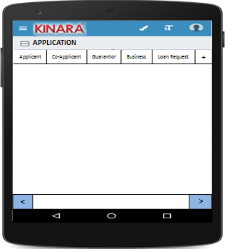

**4.2.1 Applicant**

Entity wise data capture will start with Applicant

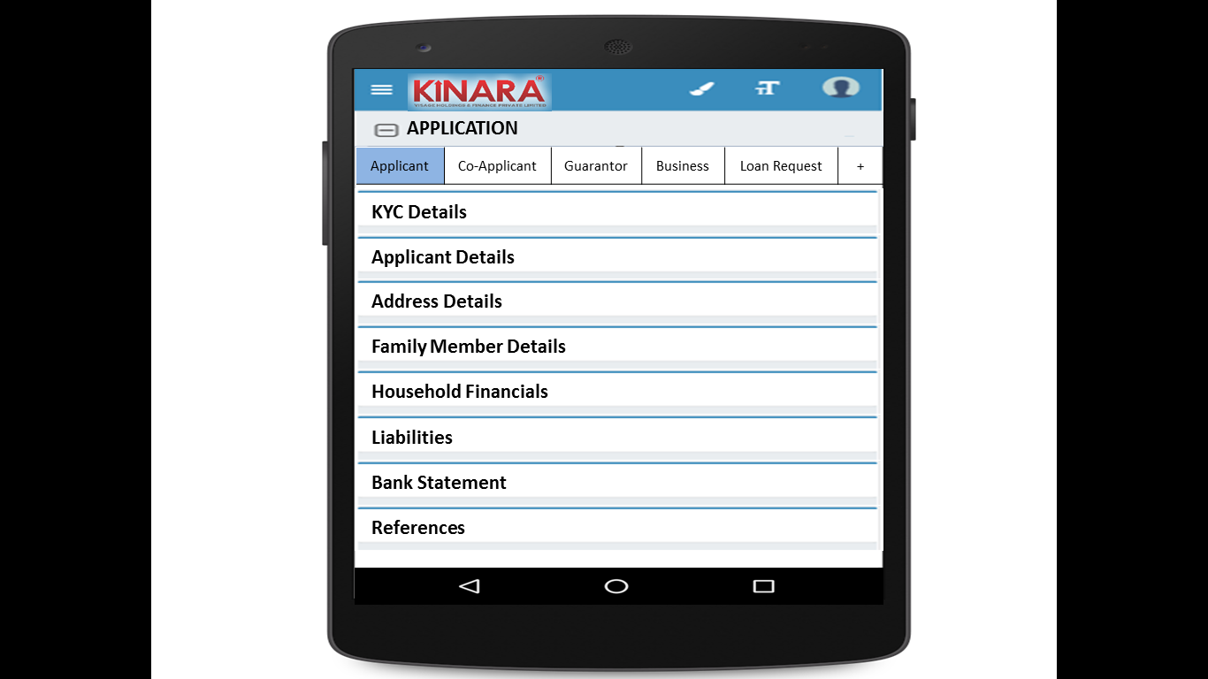

* + - 1. KYC Details:

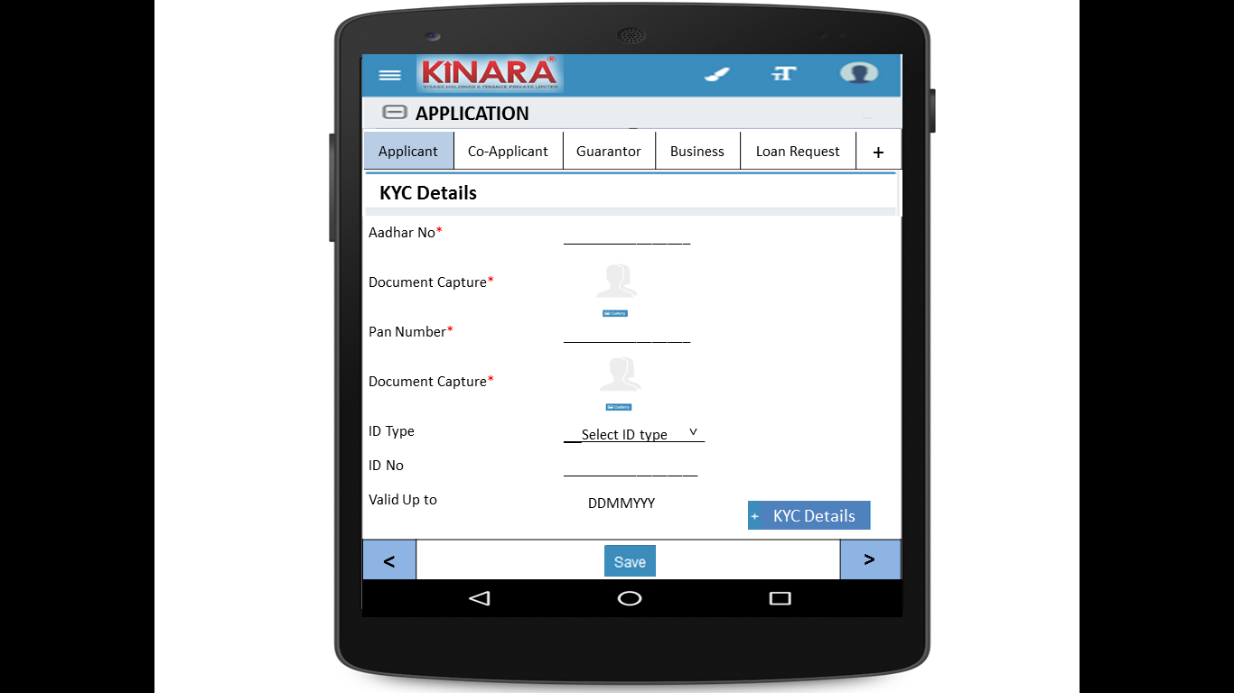

* + - 1. Applicant Details

|  |  |  |
| --- | --- | --- |
| Page 1 | Page 2 | Page 3 |

* + - 1. Address Details

|  |  |
| --- | --- |
| Page 1 | Page 2 |
| Page 3 | Page 4 |

* + - 1. Family Member Details

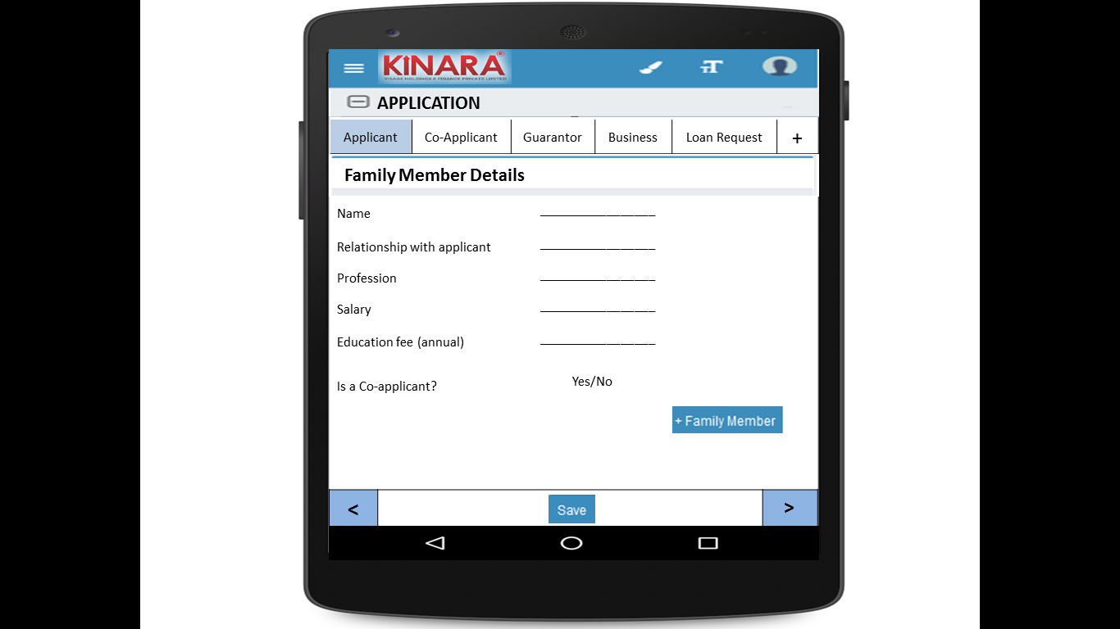

* + - 1. Household Financials

|  |  |
| --- | --- |
| Page 1 | Page 2 |

* + - 1. Liabilities

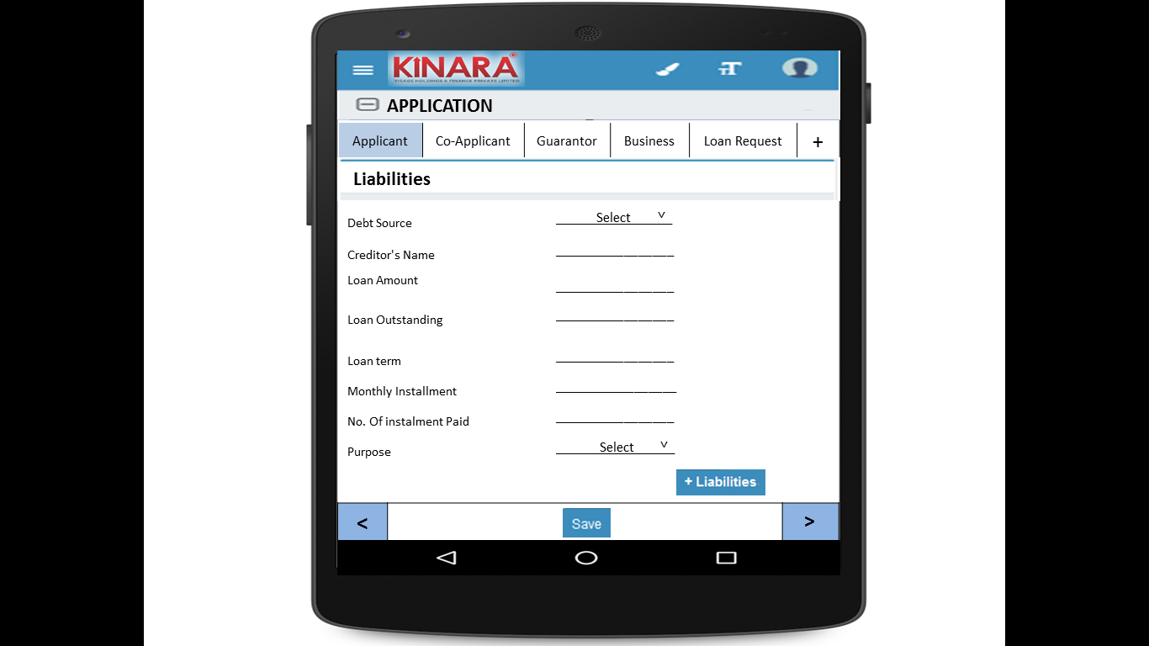

* + - 1. Bank Statement Details

|  |  |
| --- | --- |
| Page 1 | Page 2 |

* + - 1. References

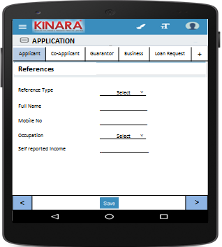

* + 1. **Co-applicant**

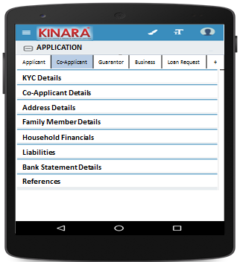

* + - 1. KYC Details

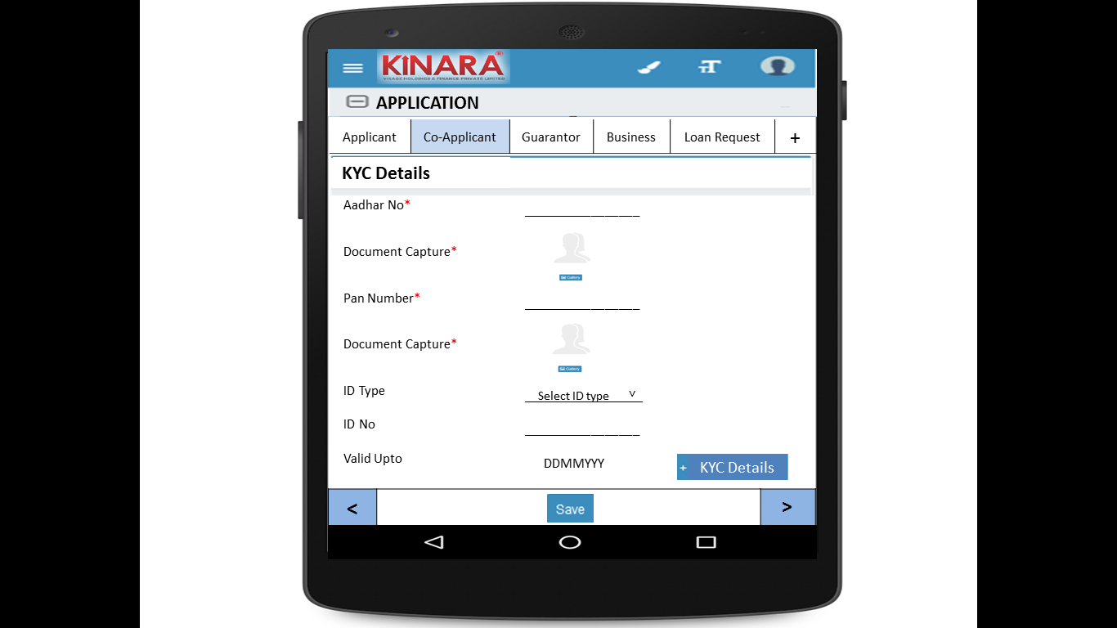

* + - 1. Co-applicant Details

|  |  |  |
| --- | --- | --- |
| Page 1 | Page 2 | Page 3 |

* + - 1. Address Details

|  |  |
| --- | --- |
| Page 1 | Page 2 |
| Page 3 | Page 4 |

* + - 1. Family Member Details

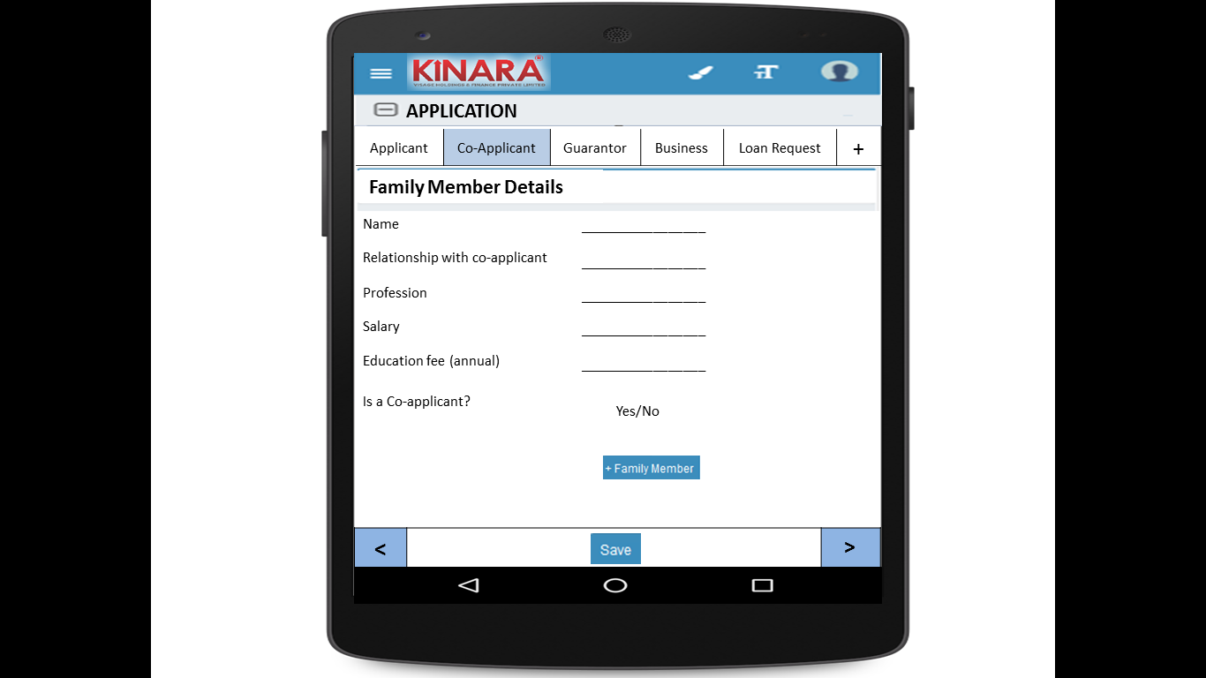

* + - 1. Household Financials

|  |  |
| --- | --- |
| Page 1 | Page 2 |

* + - 1. Liabilities

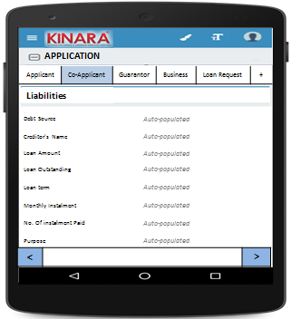

* + - 1. Bank Statement Details

|  |  |
| --- | --- |
| Page 1 | Page 2 |

* + 1. **Guarantor**

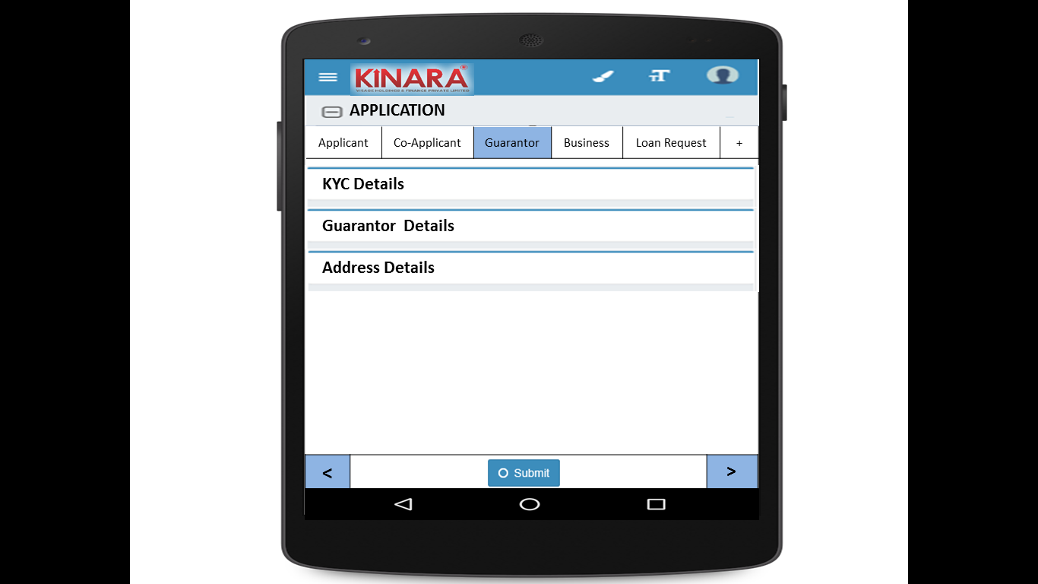

* + - 1. KYC Details

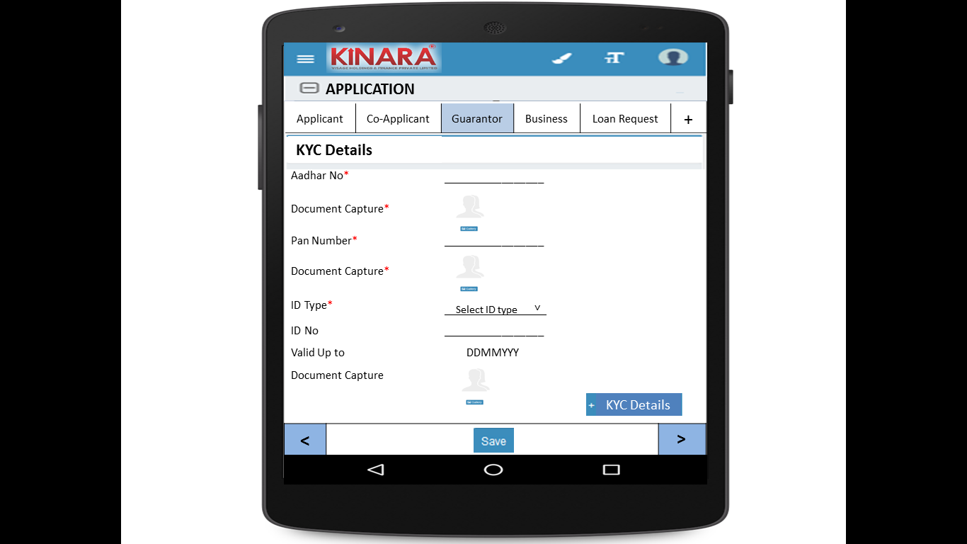

* + - 1. Guarantor Details

|  |  |  |
| --- | --- | --- |
| Page 1 | Page 2 | Page 3 |

* + - 1. Address Details

|  |  |
| --- | --- |
| Page 1 | Page 2 |
| Page 3 | Page 4 |

* + 1. **Business**

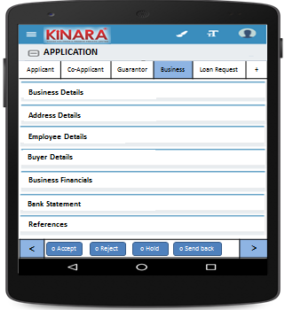

* + - 1. Business Details

|  |  |  |
| --- | --- | --- |
| Page 1 | Page 2 | Page 3 |

* + - 1. Address Details

|  |  |
| --- | --- |
| Page 1 | Page 2 |

* + - 1. Employee Details

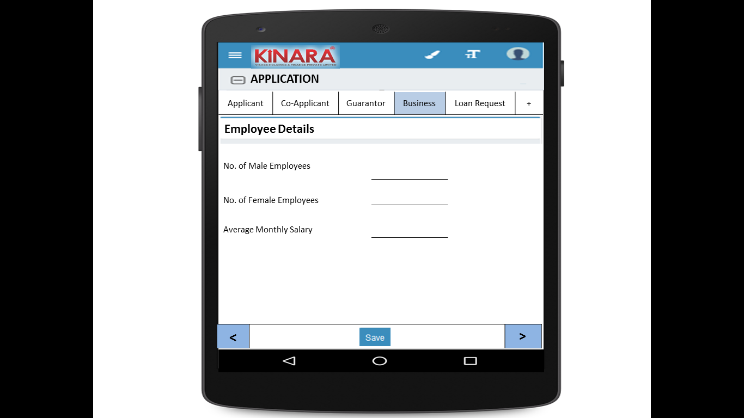

* + - 1. Buyer Details

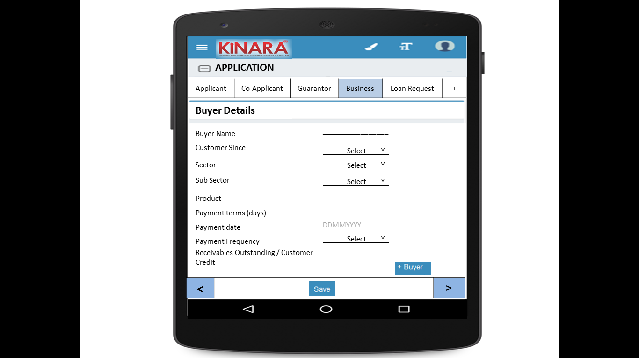

* + - 1. Business Financials

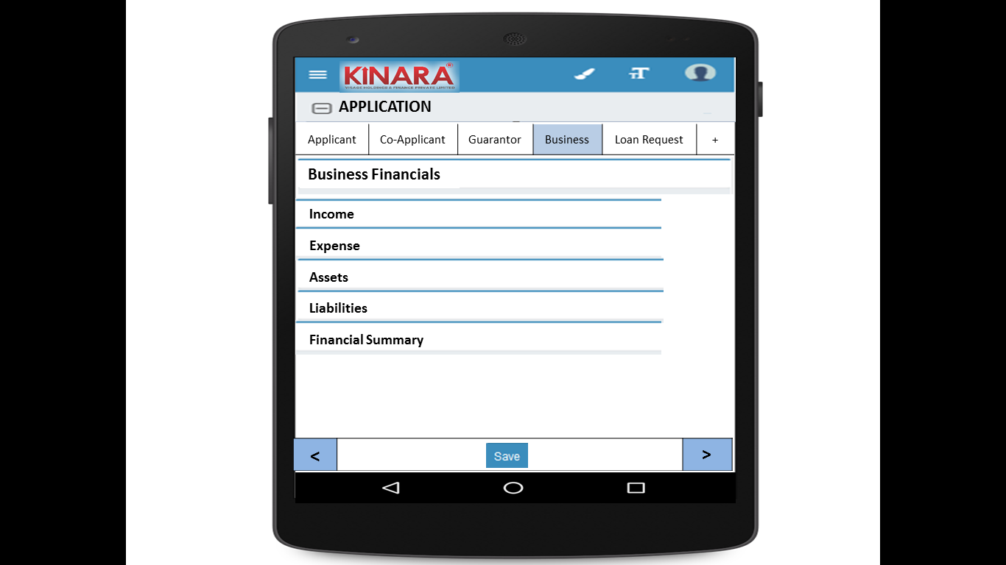

* + - * 1. Income

|  |  |
| --- | --- |
| Page 1 – Through Sales | Page 2 – Other Business Income |

* + - * 1. Expense

|  |  |
| --- | --- |
| Page 1- Raw material expense | Page 2 – Salary and wages |
| Page 3 – Fixed Obligations | Page 4 – Other Expenses |

* + - * 1. Assets

|  |  |
| --- | --- |
| Page 1 – Current Assets | Page 2 – Inventory |
| Page 3 – Machinery (1) | Page 4 – Machinery(2) |
| Page 5 – Other Assets | |

* + - * 1. Liabilities

|  |  |
| --- | --- |
| Page 1 – Fixed | Page 2 – Current |

* + - * 1. Financial Summary

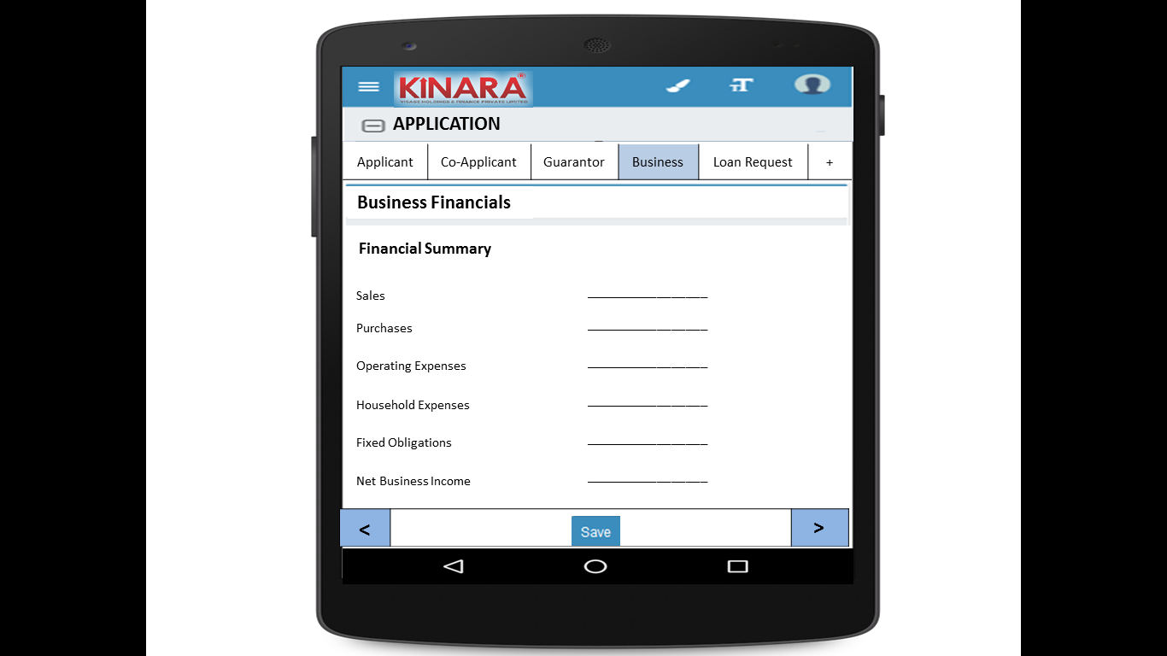

* + - 1. Bank Statement

|  |  |
| --- | --- |
| Page 1 | Page 2 |

* + - 1. References

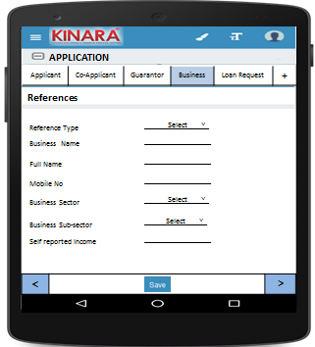

* + 1. **Loan Request**

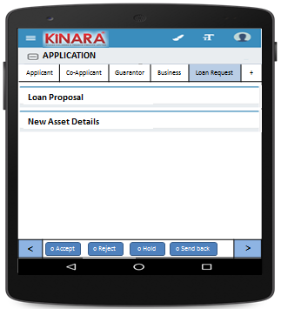

* + - 1. Loan Proposal

|  |  |
| --- | --- |
| Page 1 | Page 2 |

* + - 1. New Asset Details

|  |  |
| --- | --- |
| Page 1 | Page 2 |

## Functional requirements

* 1. Once the profile is selected from the application queue, the Loan Officer captures the application details data and submits the profile to undergo calculation of risk score 2 and an application review.
  2. Psychometric Test is also included in this stage
  3. Risk Score 2 will be calculated at the back-end on submission.
  4. All applications will be sent for application review (Auto-approval facility should also be included)

## Uploads

-NA-

## Downloads

-NA-

## Reports

-NA-

# PSYCHOMETRIC TEST

Refer Psychometric BRD for psychometric test

# RISK SCORE 2

## UI specification

-NA-

## Screenshot

-NA-

## Functional requirements

Risk Score 2 will be calculated by the system on submission of application details. The score will be calculated at the back-end on the basis of the following logic.

|  |  |  |  |  |  |  |  |  |  |  |  |  |  |  |
| --- | --- | --- | --- | --- | --- | --- | --- | --- | --- | --- | --- | --- | --- | --- |
| **S.No** | **Parameter** | **Stage** | **Entity** | **Main Tab** | **Field Name** | **Options** | **RS Option** | **Weightage in consolidated risk score** | **Weightage in screening score** | **Scoring** | | | | |
| **1** | **2** | **3** | **4** | **5** |
| 1 | Age | Application | Applicant | Applicant Details | Age |  | 1. < 25 2. 25 - 30 3. 30 - 40 4. 40 - 55 5. > 55 | 2 | 2/53 | 1 | 3 | 5 | 5 | 2 |
| 2 | Qualification | Application | Applicant | Applicant Details | Education Level |  | 1. Below SSLC 2. ITI/Diploma/ Professional Qualification 3. Graduate/ Equivalent to graduate 4. Post graduate & equivalent 5. More than post-graduation | 1 | 1/53 | 1 | 5 | 3 | 4 | 3 |
| 3 | Exp in Biz | Application | Applicant |  |  |  | 1. <2 years 2. 2-3 years 3. 3-4 years 4. 4-5 years 5. >5 years | 3 | 3/53 | 1 | 2 | 3 | 4 | 5 |
| 4 | # of Years residence in area /Locality | Application | Applicant | Address Details | How many years are you living in present Area? |  | 1. < 1 year 2. 1-3 years 3. 3-4 years 4.4-5 years 5. > 5years | 1 | 1/53 | 1 | 2 | 3 | 4 | 5 |
| 5 | Housing Status | Application | Applicant | Address Details | Ownership |  | 1. Owned 2. Own house without registration 3. Family Property 4. Leased 5. Rental | 2 | 2/53 | 5 | 4 | 3 | 2 | 1 |
| 6 | Married Status | Application | Applicant | Applicant Details | Marital Status |  | 1. Unmarried 2. Married 3. Separated 4. Divorced 5. Widow(er) | 1 | 1/53 | 4 | 5 | 0 | 1 | 3 |
| 7 | Involvement in Biz | Application | Applicant | Applicant Details | Business Involvement |  | 1. Full Time 2. Part Time 3. Not Involved | 3 | 3/53 | 5 | 3 | 0 |  |  |
| 8 | CB score | Screening | Applicant |  |  |  | 1. No data/ -1 to 5 2. 700+ 3. 600-700 4. 550-600 5.<550 | 6 | 6/53 | 3 | 5 | 4 | 2 | 0 |
| 9 | Psychometric Score | Application | Summary | Psychometric Test | Psychometric Score |  | 1. Failed in all parameters 2. Failed in more than 3 parameters 3. Failed in 2 parameters 4. Passed in 5 of 6 parameters 5. Passed in all parameters | 1 | 1/53 | 0 | 2 | 3 | 4 | 5 |
| 10 | Referred by | Application | Business | Business Details | Referred by |  | 1. Channel Partner 2. Existing Customer Referral 3. Direct (Cold Call) 4. Referral Partner | 2 | 2/53 | 5 | 3 | 1 | 2 |  |
| 11 | Business Vintage (verifiable) | Application | Business | Business Details | Business Operating since |  | 1. <6 months 2. 6 months to 1 year 3. 1-2 years 4. 2-3 years 5. >3 years | 3 | 3/53 | 1 | 2 | 3 | 4 | 5 |
| 12 | # of Years business in area /Locality | Application | Business | Business Details | How many years business in present Area? |  | 1. <6 months 2. 6 months to 1 year 3. 1-2 years 4. 2-3 years 5. >3 years | 5 | 5/53 | 0 | 1 | 2 | 3 | 5 |
| 13 | Business premises Status | Application | Business | Business Details | Ownership |  | 1. Owned 2. Own house without registration 3. Family Property 4. Leased 5. Rental | 2 | 2/53 | 5 | 4 | 3 | 2 | 1 |
| 14 | Business History | Application | Business | Business Details | Constitution | 1. Proprietorship  2. Partnership 3. Private LTD | 1. Clean - Single owner/ Structure | 2 | 2/53 | 5 | 4 | 3 | 1 | 2 |
| Business | Business Details | Constitution | 1. Proprietorship  2. Partnership 3. Private LTD | 2. Partnership with 2 partners |
| If partnership, how many total partners | 1. 2  2. 3 3. 4 4. >4 |
| Business | Business Details | Constitution | 1. Proprietorship  2. Partnership 3. Private LTD | 3. Partnership with more than 2 partners |
| If partnership, how many total partners | 1. 2  2. 3 3. 4 4. >4 |
| Applicant | Applicant Details | Have you ever been a proprietor or partner of any other company | 1. Yes 2. No | 4. Previously closed another business |
| If yes, did the business close? | 1. Yes 2. No |
| Business | Business Details | Has anyone else been a partner of your present business | 1. Yes 2. No | 5. Previously dissolved partnership |
| If yes, when was that partnership dissolved? | Date |
| 15 | Commercial High mark / CIBIL | Screening | Business | CB Check |  |  | 1. No Data 2. STD 3. Sub DBT, Loss | 5 | 5/53 | 3 | 5 | 0 |  |  |
| 16 | No of cheque returns including EMIs | Application | Business | Bank Statement Details | No. of cheques bounced |  | 1. 0-1 2. 2-3 3. 3-4 4. 4-6 5. >6 | 4 | 4/53 | 5 | 4 | 3 | 1 | 0 |
| 17 | Number of EMI bounces | Application | Business | Bank Statement Details | No of EMI cheques bounced |  | 1. No Bounces 2. Technical Bounces paid in same month 3. 3 bounces paid in same month 4. >3 bounces paid after the month | 5 | 5/53 | 5 | 4 | 2 | 0 |  |
| 18 | No of Bounces in Kinara loan track |  |  |  |  | From Kinara records for existing customer ID for applicant/ Business | 1. No Bounces 2. Technical Bounces paid in same month 3. 2 bounces paid in same month 4. >2 bounces paid after the month | 5 | 5/53 | 5 | 4 | 2 | 0 |  |
| **CONSOLIDATED** | | | | | | | | **53** | **100%** |  |  |  |  |  |

## Upload

NA

## Download

NA

## Reports

Customer wise Risk Score & Psychometric Score

# List of Abbreviations

|  |  |
| --- | --- |
|  | **Abbreviations** |
| ABB | Average Bank Balance |
| BRD | Business Requirement Document |
| CB Report | Credit Bureau Report |
| CC | Credit Committee |
| CIBIL | Credit Information Bureau (India) Limited |
| CRM | Central Risk Manager |
| CRO | Credit Risk Officer |
| DO Partner | Direct Origination Partner |
| DPD | Days Past Due |
| DSCR | Debt Servicing Capability Ratio |
| DSO | Days Sales Outstanding |
| EMI | Equated Monthly Instalments |
| FRO | Field Risk Officer |
| HM | Hub Manager |
| ITR | Income Tax Return |
| LCRDS | Line of Credit RFD - Secured |
| LCRDU | Line of Credit RFD - Unsecured |
| LCRIS | Line of Credit RFID - Secured |
| LCRIU | Line of Credit RFID - Unsecured |
| LO | Loan Officer |
| LTV | Loan To Value |
| LUC | Loan Utilisation Check |
| POC | Point of Contact |
| RS 1 | Risk Score 1 |
| RS 2 | Risk Score 2 |
| RS 3 | Risk Score 3 |
| SCAPS | Shriram City Asset Purchase - Secured |
| SCBDS | Shriram City Business Development - Secured |
| SCBDU | Shriram City Business Development - Unsecured |
| SCMFS | Shriram City Machine Refinance - Secured |
| SCWCS | Shriram City Working Capital - Unsecured |
| SCWCU | Shriram City Working Capital - Secured |
| TLAPS | Term Loan Asset Purchase - Secured |
| TLBDS | Term Loan Business Development - Secured |
| TLBDU | Term Loan Business Development - Unsecured |
| TLMFS | Term Loan Machine Refinance - Secured |
| TLWCS | Term Loan Working Capital - Unsecured |
| TLWCU | Term Loan Working Capital - Secured |
| URN | Unique Registration Number |
| WC | Working Capital |